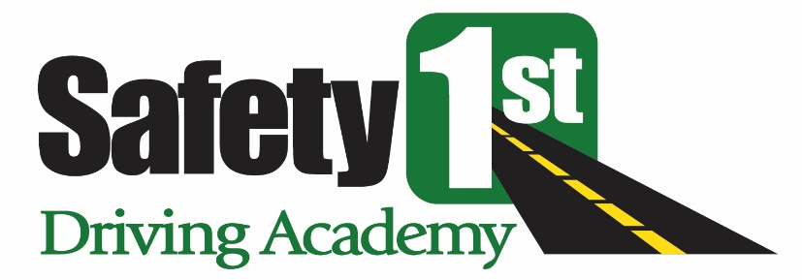

Safety 1st Driving Academy, Inc. Registration Agreement
The terms and conditions set forth in this Registration Agreement (“Agreement”) create a contract between you and Safety 1st Driving Academy, Inc. (“Safety 1st”). Please read this Agreement carefully. Children should review this Agreement with their parent or legal guardian to ensure that the child and parent or legal guardian understands it fully. To confirm your understanding and acceptance of this Agreement click “Agree”. You will also be required to sign an original of this Agreement and deliver it to Safety 1st Driving Academy, Inc. at 385 Court Street, Suite 104, Plymouth, MA 02360.
- SERVICES
Safety 1st shall provide driver education and other services and you shall pay for those services you elect to receive in accordance with the attached List of Services.
- TIME FOR COMPLETION
Students that participate in the Safety 1st driver’s education full course shall have a maximum of two years to complete this program from their start date of the course, as mandated by the Massachusetts Registry of Motor Vehicles. If the program is not completed within said two year time period, students shall not be able to obtain the driver’s education completion certificate and will be required to complete a new program from the beginning and pay all fees and costs therefore. No credit or refund shall be made for any previously paid monies to Safety 1st.
3. SERVICES USAGE RULES AND REQUIREMENTS
- All students shall strictly comply with the policies, rules and conditions set forth by Safety 1st as they exist at the time of registration or otherwise may change from time to time.
- Students shall not be disruptive. They shall be respectful of fellow classmates, Safety 1st personnel and all other individuals they come in contact with during the program. This includes both classroom and behind-the-wheel instruction. They shall not damage any property of Safety 1st. They shall not disrupt or interfere with any of the other businesses located in the building where Safety 1st conducts the program. No loitering or wandering within said building shall be permitted. A violation of this provision may lead to immediate dismissal of the student who shall not be allowed to continue with the program until a meeting occurs between Safety 1st and the student and parent or legal guardian and Safety 1st is satisfied that the student may continue with the program.
- Students may be given unsupervised breaks during certain classroom sessions. Students may remain in the Safety 1st classroom/ office suite during these breaks. In the event students elect to leave the Safety 1st classroom/ office suite during any such break, Safety 1st shall not be responsible for said students or any damages or injuries they might incur or cause. Students must return to the classroom on time. If they fail to do so, Safety 1st may preclude them from completing the classroom session.
- Safety 1st has the sole discretion to deny a student sponsorship for the State License Examination, if it feels that the student is not sufficiently knowledgeable and competent for said Examination.

4. OTHER PROVISIONS

- Parents and legal guardians must complete the Registry of Motor Vehicle’s mandated 2 hour class or show proof of a completion certificate that they have completed the class within a prior five year period before any driving time is scheduled.
- All driving times must be scheduled online or directly with the driving instructor. Driving times may only be cancelled online and you must give a minimum of 24 hours advance notice of cancellation prior to the scheduled driving time. In the event 24 hours notice is not given, a $50 cancellation fee shall be charged.
- The student should be available at the pick-up location at least 15 minutes prior to the scheduled driving time. Instructors will wait a maximum of 10 minutes after the scheduled driving time if the student is not available. If the student is not available, a $50 late fee shall be charged.
- Any payment to Safety 1st that is non-sufficient, either by credit card or check, shall result in a $35 fee. In addition, any refund given by Safety 1st shall be subject to a $35 administrative processing fee.
- Optional payment plans may be offered by Safety 1st at its sole discretion. The terms and conditions shall be determined exclusively by Safety 1st and must be strictly complied with. Any cancellation or other fees due to Safety 1st must be paid prior to the student scheduling their next driving time.
- Safety 1st has the sole discretion to cancel any classroom session that has an enrollment of less than six (6) students.

5. TERMINATION/CANCELLATION

All payments and fees for services, cancellation and otherwise, are non-refundable and deemed earned upon assessment. However, Safety 1st, in its sole discretion, may, but shall not be obligated to refund monies paid, in exceptional circumstances. There shall be absolutely no refund of monies paid by Safety 1st to any third party. Safety 1st reserves the right to terminate/cancel this Agreement at any time for violations of the terms and conditions herein and shall not be obligated to refund monies paid pursuant to the provisions of this Agreement in the event of any such violation. All cancellation fees, damage assessments and other monies due shall be paid prior to your receiving any services from Safety 1st.
6. DAMAGES LIABILITY

You shall be responsible for any and all damages you cause to any vehicle or other property, including, without limitation, any insurance deductibles assessed, as a result of operation of our vehicles or other conduct.

- LIMITATION OF LIABILITY

To the extent permitted by applicable law, in no event shall Safety 1st, its affiliates, agents, employees or principals be liable for personal injury, property damage, or any incidental, special, indirect or consequential damages whatsoever sustained by you or sustained by any other person or entity as a result of your participation in any Safety 1st program or use of Safety 1st property. You shall save and hold Safety 1st harmless and indemnify Safety 1st from any and all such losses and damages occurring due to any omission, fault, neglect or other misconduct by you.

The undersigned acknowledge that they have read, understand and agree to the above.

Student Signature:__________________________________ ___________Date:____________
Print Name:__________________________________________________
Parent/Legal Guardian Signature:_____________________ ____________ Date:____________
Print Name:__________________________________________________

